Digital Nurture 4.0 – Week 3
Spring core & maven

Exercise 1: Configuring a Basic Spring Application
Set up a basic Spring Maven project for library management by creating service and repository classes, configuring beans in an XML file, and running them through a main class.

PROGRAM
pom.xml
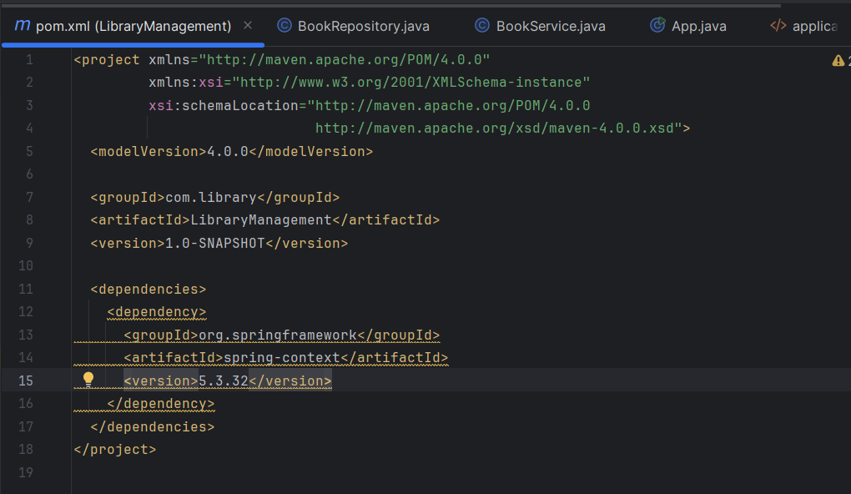

BookRepository.java
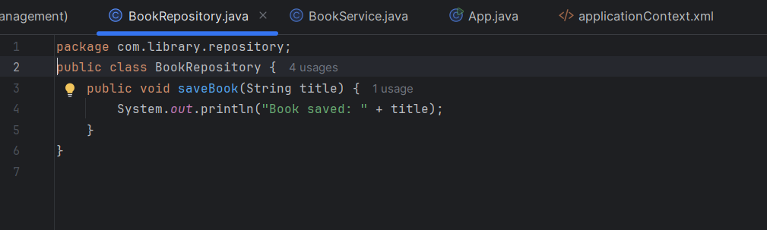

BookService.java
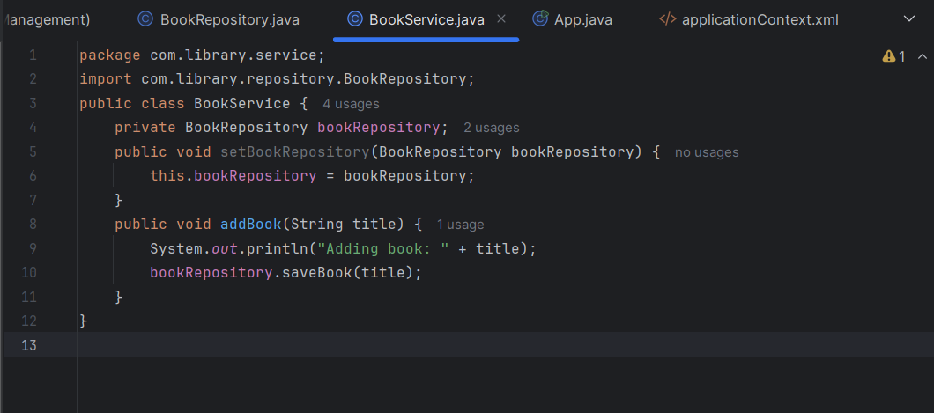

App.java
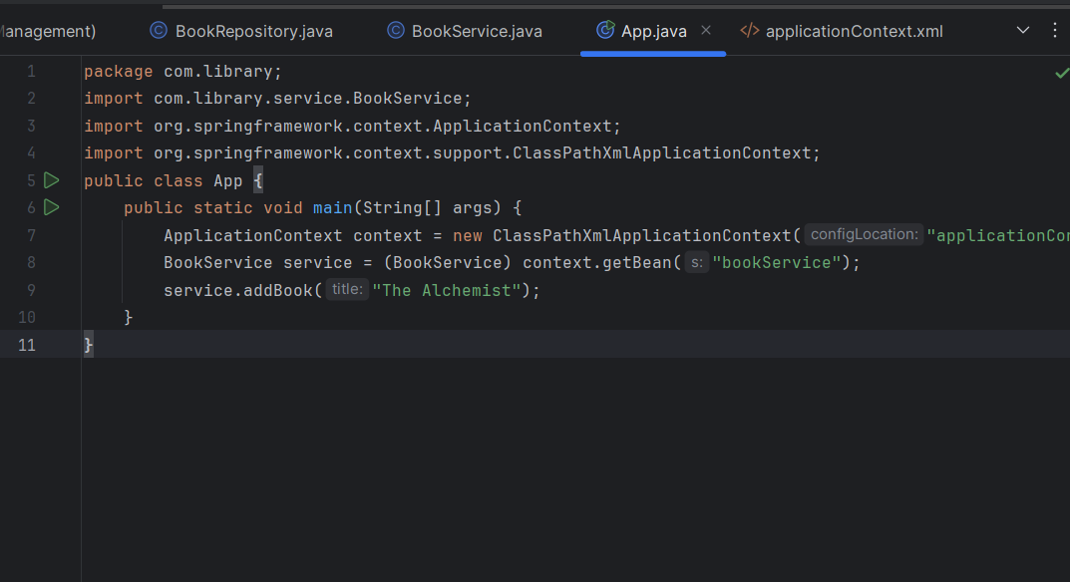

applicationContext.xml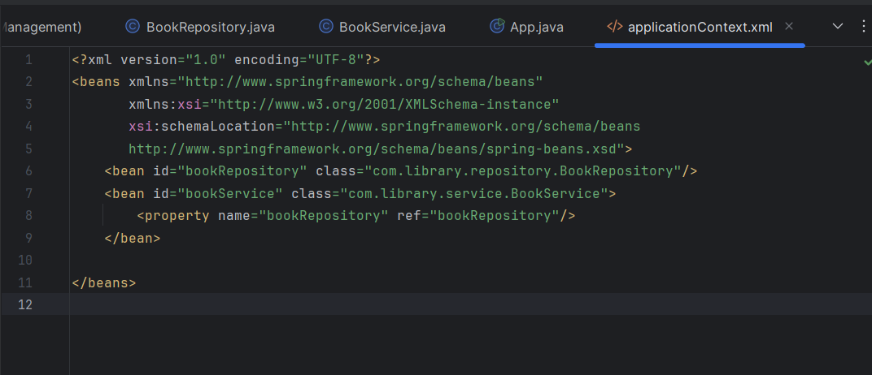

OUTPUT
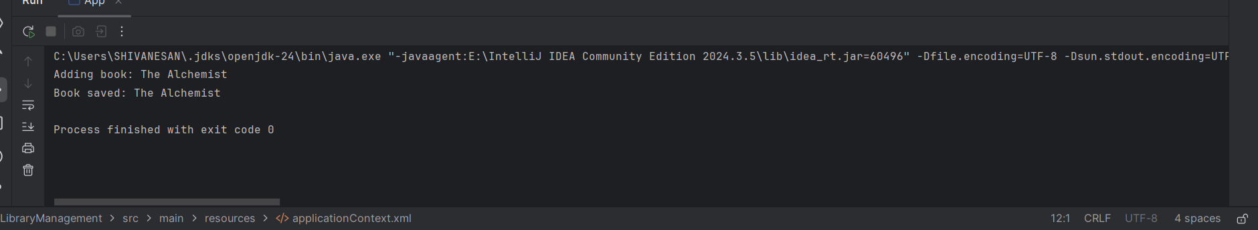

Exercise 2: Implementing Dependency Injection
Use Spring's XML-based dependency injection to wire BookRepository into BookService via a setter method and verify it by running the application.

PROGRAM
pom.xml
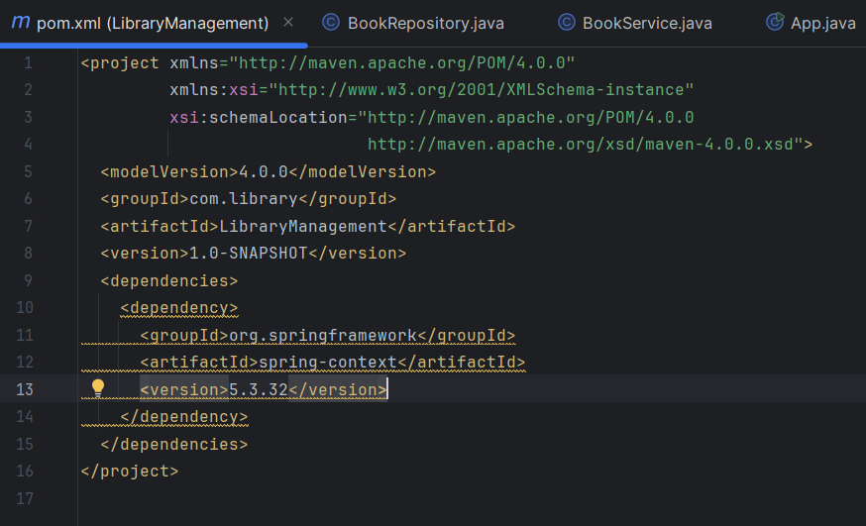

BookRepository.java
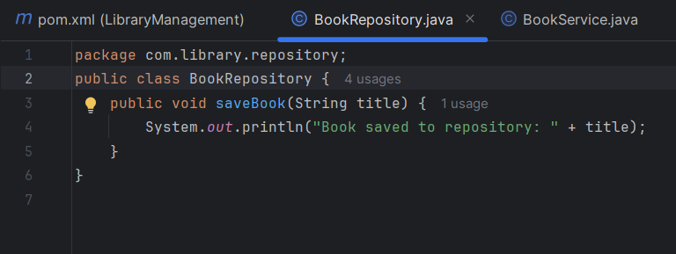

BookService.java
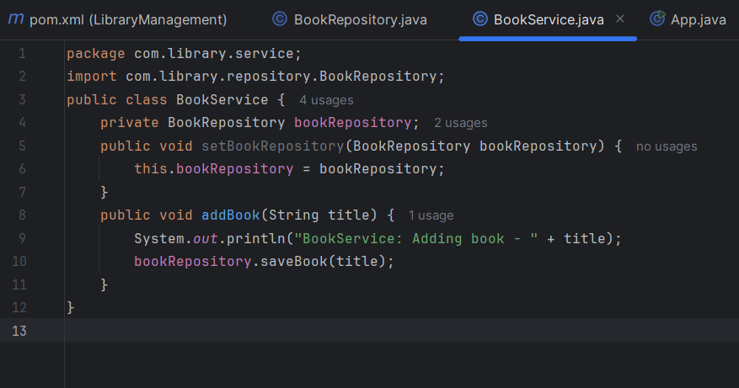

App.java
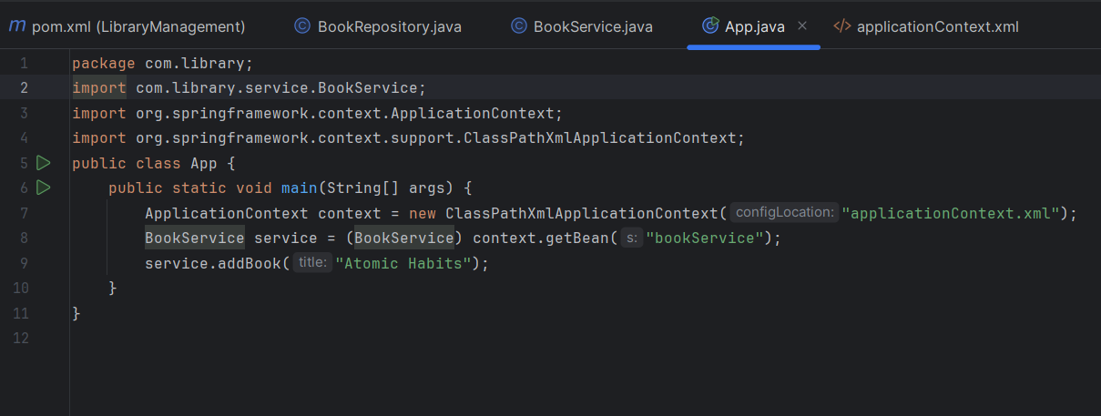

applicationContext.xml
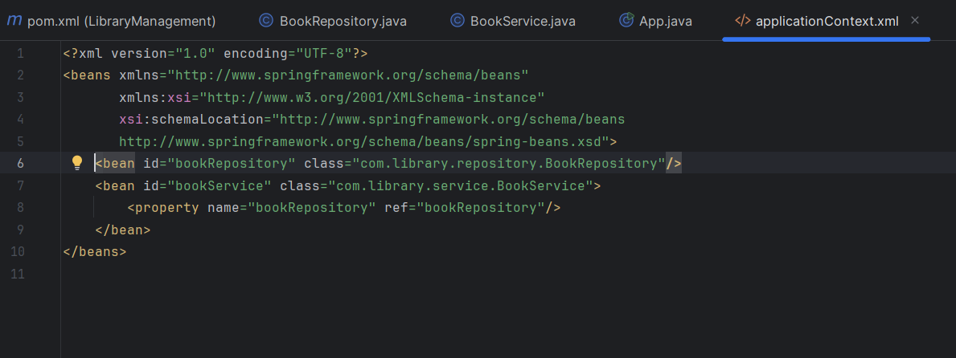

OUTPUT
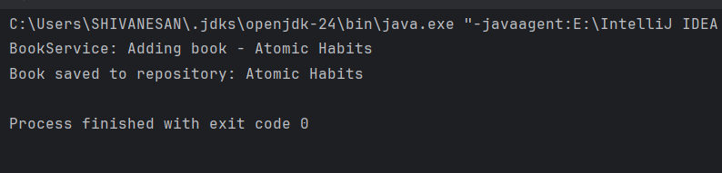

Exercise 4: Creating and Configuring a Maven Project
Create a Maven project named LibraryManagement, add Spring Context, AOP, and WebMVC dependencies, and configure the Maven Compiler Plugin for Java 1.8 in the pom.xml

PROGRAM
pom.xml
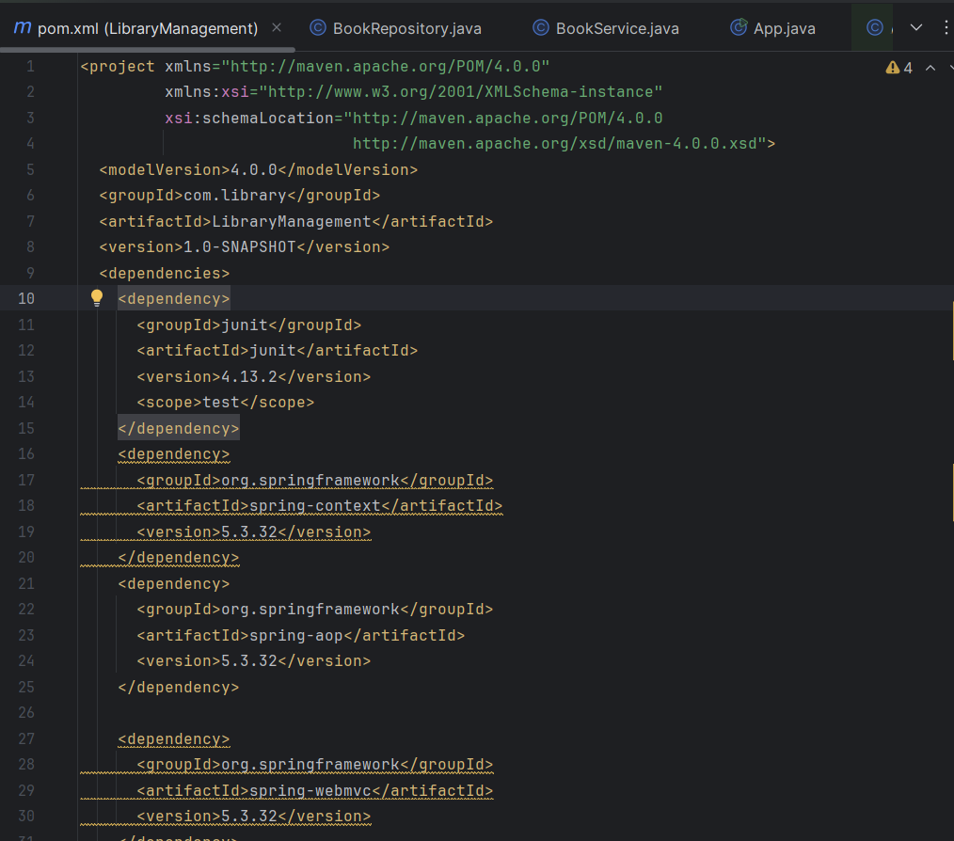
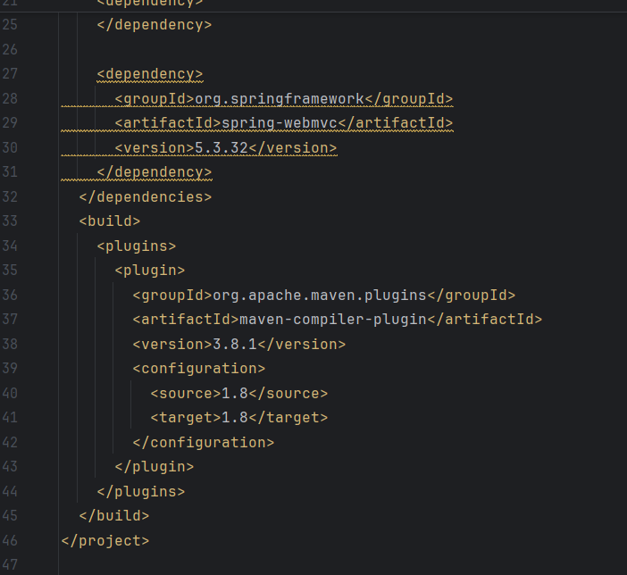

OUTPUT
